DRIVERS OF ENGAGEMENT

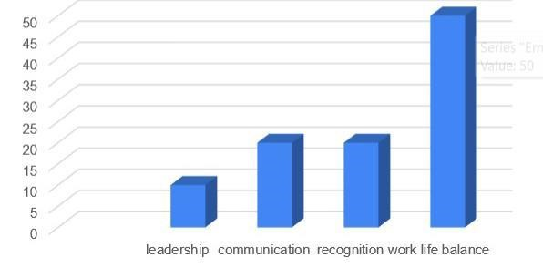

KEY DRIVERS OF EMPLOYEE ENGAGEMENT



EMPLOYEE ENGAGEMENT